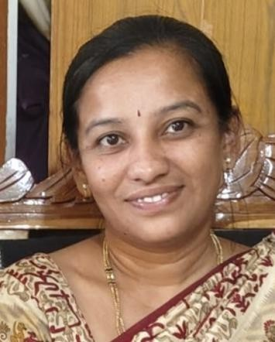

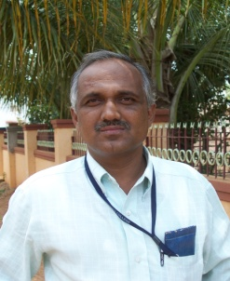

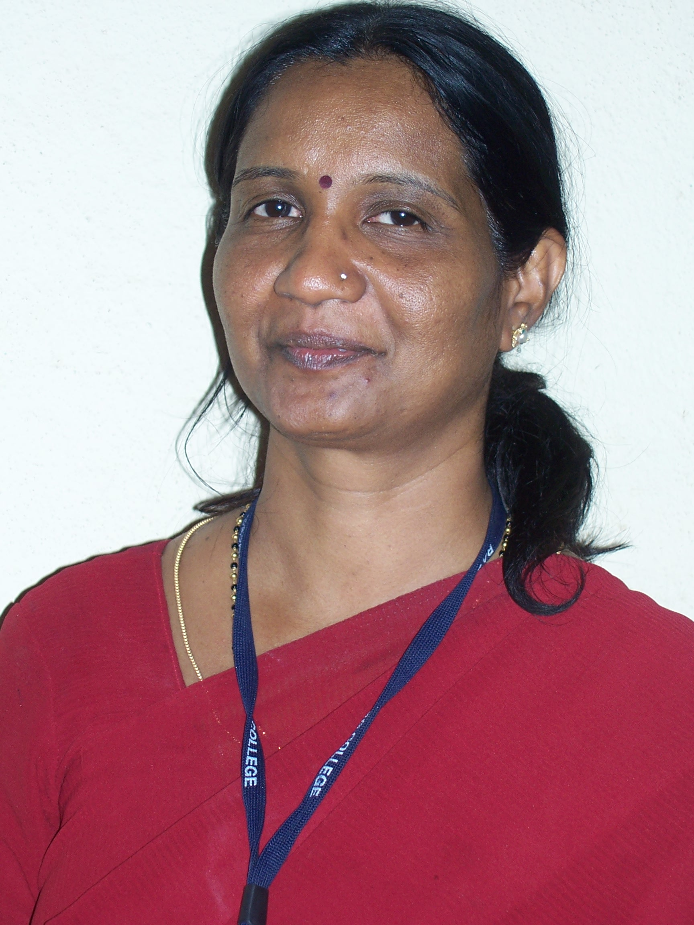

Conferences/ Symposiums/ Workshops/ Training
ProgramsAttended

: NPTELOnlineCourse:
- NPTEL CertificationonIntroductionto SmartGrid08 weeks’ courseconducted byIIT Roorkee on July-Sep 2019
- NPTEL EliteCertification onTeaching andLearning inGeneralPrograms04weeks course conducted by IISC Bangalore on Sep-Oct2020

- NPTELCertificationonAdvancesinUHV Transmissionand Distribution08weeks’ course conducted by IISC Bangalore on Sep – Nov 2020
- NPTELCertification on Design thinking 04 weeks course conducted byIITMadrason August – Sep 2023

- NPTEL Certification on DC Grid and Control System 08 weeks course conducted by IIT Roorkee on July-Sep 2024

SpokenTutorialOnlineCourse:
- AspokentutorialtrainingprogramonPython3.4.3organizedPadmabhooshanVasantraoda PatilInstituteofTechnology,Budhgaon onMay2nd2020.Fundedby National Mission on Education through ICT, MHRD.Govt., of India IIT Bombay
- Aspoken tutorialtrainingprogramon“OpenModelicaandOpenIPSL”hostedbyV.K.R,
V.N.B & A,G.K college of engineering, Gudivada on 17thjune to 23rd june 2020. Funded by National Mission on Education through ICT, MHRD.Govt., ofIndia IIT Bombay Conferences/ Symposiums/ Workshops/ TrainingPrograms Attended
- Faculty development programme on ‘Biology for Engineers’ conducted at Basaveshwar Engineering College, Bagalkot under TEQIP-II by IIT Bombayduring February 01-04, 2017.
- Two days international symposium on “Green Technologies for Sustainable Development”Organized on24th&25thFebruary,2017underTEQIP –IIatBasaveshwar Engineering College, Bagalkot.
- Faculty Development programme on “Recent Advances in Signal Processing and Communication Networks” jointly organized by Department of Electronics communication engineering and Department of Telecommunication engineering, Goa during 17-03-2017 to 19-03-2017 underTEQIP – II of world bank.
- Three days faculty development program on teaching learning organized and conducted by IIT Madras from 6th to 8th October 2017
- One day seminar on “Industrial Electrical Safety & open hall Interaction” on Saturday, 29thjuly 2017 at Shanthala Bhavan Hubballi.
- Two days workshop on “sensors Networks “during 8th to 9th January2018 Organized and conducted by TEQIP-III at BEC Bagalkot.
- Three days training programme on Development positive Attitude towards Institutional Works and Life conducted by Saitej Life Training Institute organized by NPIU Govt. of india during 12th to 14th October 2018.
- One week faculty development Programme on “Electrical Vehicle – Electrical Machine Drives, Power Converters and Latest Technologies” from 22nd – 26th July 2019 Organized by Basaveshwar Engineering College Bagalkot by Department of Electrical and Electronics.
- Two day workshop on AICTE examination Reforms, during 14th February and 15th February 2020 conducted by Basaveshwar Engineering College Bagalkot and Organized by TEQIP-III and NPIU.
- ActivelyparticipatedinVirtualyoga,BuildingResilienceinBody&Mindheldon Thursday, 28th April 2020 organized IEEE Bangalore Section.
- DigitaltransformationinteachinglearningProcessFeb14tomarch6th2020 under TQIP -3 Sponsored and organized by IIT Bombay.
- An online course, recognized by Skill Council for Green Jobs, conducted from 01 May 2019 to 31 Dec 2019for Student Solar Ambassador Workshop 2019.This course isoffered by IIT BombayX, an online learning initiative of Indian Institute of Technology Bombay.
- OneweekonlinefacultyDevelopmentprogrammeon“PowerElectronicApplicationsto

Renewable energy systems and Energy storage systems” held from July 06-10, 2020 under TEQIP -3 Sponsored and organized by NIE Mysore.
  - One week online AICTE STTP on “Optimal operation of power system Incorporating RenewableEnergyResources,OrganizedbySagarInstituteof ResearchandTechnology, Bhopal.
  - “Innovation and Entrepreneurship in a Post-Covid World” Held from 22nd June to 29th June 2020, as NPTEL Special Lecture Series, Co-organized by National Digital Library of India.
  - NDLI User Awareness Webinar held on 29th July, 2020 organized by the NationalDigital Library of India in collaboration with the Einstein College of Arts and Science, Tirunelveli.
  - One week STTP on “Recent Trends in Power Electronics, Power Systemand Renewable Energy System-II (RTPEPSRES-II-2020)” during 03.08.2020 to 07.08.2020, organized by the Department of Electrical Engineering, National Institute of Technology, Raipur, CG.
  - One day webinar on “E-Resources for technology and Management research beyondVTU consortium” on 26/02/2021 Organized by Library and Information centre andIQAC Centre of PES college of Engineering Mandya.
  - “Recent trends in power systems and power electronics” from 25th to 27th March 2021, Organized by Department of E&E Pooja DoddappaAppa College of Engineering, Kalburgi under TEQIP-III.
  - AICTE sponsored one Week online STTP on “Recent Advances in EV Technologies, series-D organized by Dept of E&E Matrushi Engineering College during 12th July to 17th July 2021.
  - Recent Advancement in Electric vehicle technology funded by New Gen IEDC, DST, Govt of india, Organized by dept of E&E BNMIT Banglore 18th to 23rd October 2021.
  - National symposium on “Energy Conservation Awareness and Practices” Organized by The Institute of Engineers Karnataka state centre in Association with BNMIT Banglore on 14th December 2021
  - Online Workshop on “Recent Developments in Smart Grid and Applications” in association with VTU, Belagavi and IEEE PES Chapter, from 05th - 07th September 2022, Organized by Department of Electrical and Electronics Engineering, GSSSIETW, Mysuru.
  - Twodaysworkshop on“OutcomeBasedEducation”(OBE)heldon30thsept to 1st October 2023 at Basaveshwara Engineering college Bagalkot,
  - Participated in five day workshop on “Sustainable Development: Intersection of Green Energy and e-Mobility” (IGEEM-2024) organized by Department of Electrical Engineering, NIT Rourkela and sponsored by Science and Engineering Research Board (SERB) from 16th Oct to20th Oct 2024, at National Institute of Technology Rourkela, Odisha.
  - ResearchwritingProposalTechniquestogetfundsforprojectsandSystematicprocessof feeling from patent Drafting the patent Grent's. Jointly organized by the Department of Mechanical Engineering, Ramachandra College of Engineering (A) Eluru,Andhra Pradesh, India of RSP Science Hub Coimbatore, Tamil Nadu. India during 07th - 19th December 2024.
  - One day Training Program on Fire Safety Organized by BVV Sangha old Campus Bagalkote on 8th October 2024

