FACULTY PROFILE

Name | : | Mr. Shivakumar G. Nayak | 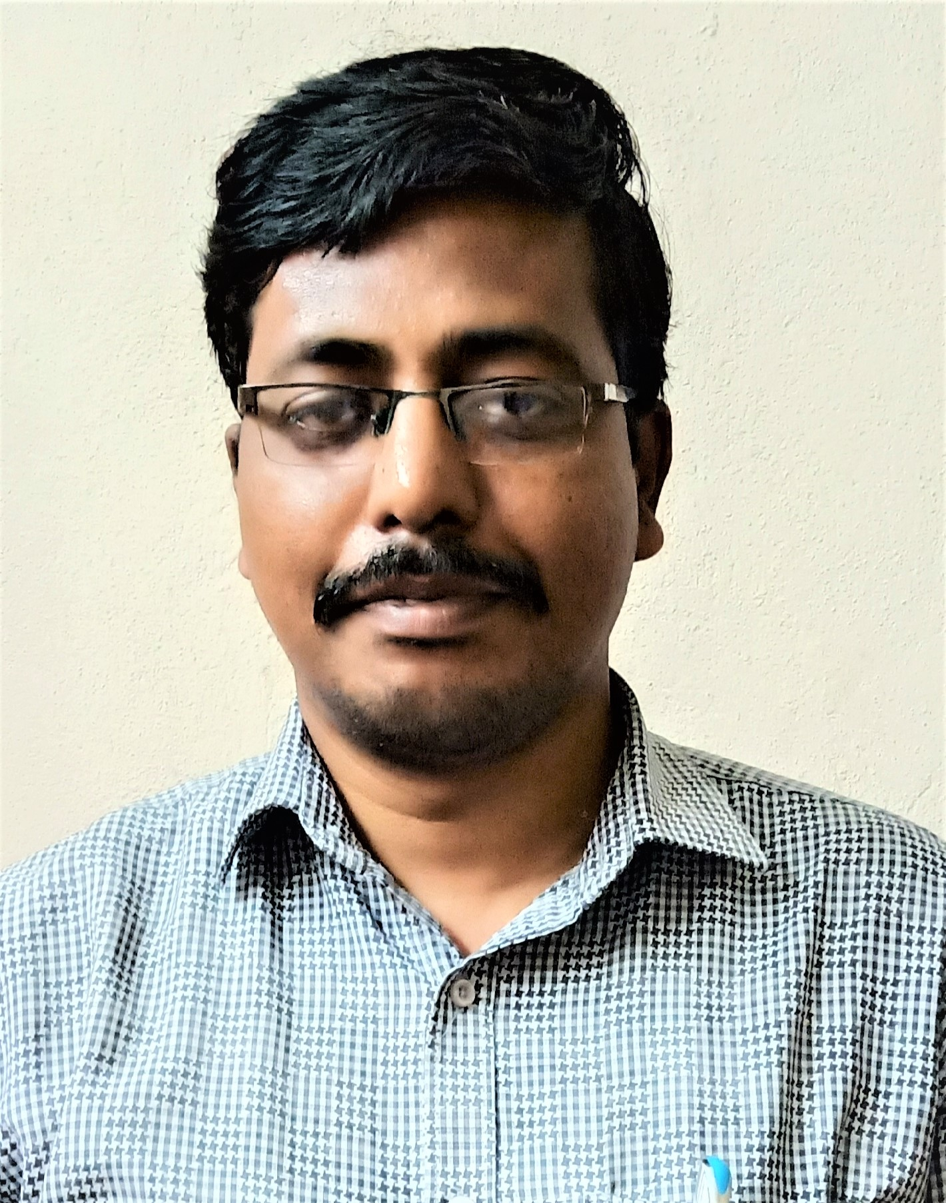Recent Photo
Designation | : | Assistant Professor
Department | : | Electrical and Electronics Engineering
Employee ID | : | TEE014
E mail ID  (College official ID), (Personal mail ID) | : | Shivakumarnayak8@gmail.com  sgnee@becbgk.edu
Contact details | : | 9738681084
Orcid ID | : | 0000-0003-3134-6453
Vidwan Id | : | 125168
Researcher ID (Web of Science) | : | GNM-5573-2022
Google Scholar ID | : | mtdQUUAAAAJ
Qualification | : | B.E. M.Tech
Teaching Experience | : | 5.5
Industry Experience | : | 00
Administrative Responsibilities | : | - Issuing Coordinator  - Anti-Ragging Member  - AICTE 360 degree Coordinator  - Department website Coordinator  - Department BOS Member
No. of Projects Guided UG | : | 09
Journals(with citations) | : | - MuskaanYadahalli, Shivakumar G. Nayak, and “Comparative Analysis of Sprinkler Irrigation System with Drip Irrigation System through IOT Module” International Journal of Advanced Research in Science, Engineering and Technology, Vol.7, Issue 7, ISSN: 2350-0328, pp 14377 – 14384, July 2020.  - Shivakumar G Nayak, Ashwini Patil, Gurubai Gadagenavar. “Development and Analysis of Speed Control of BLDC Motor with Arduino Controller”, International Journal of Innovative Technology and Exploring Engineering (IJITEE) ISSN: 2278-3075 (Online), Volume-11 Issue-4, March 2022
Conferences | : | - Smitha Pujari, Deepa kabbur, JyotiTalawar, Shivakumar G Nayak, presented paper on “Speed Control of BLDC Motor using PI Controller”, Online International Conference on “Continuity, Consistency and Innovation in Applied Sciences and Humanities (ICCIASH-2020)” Organized on 13th and 14th August, 2020. Department of Science and Humanities, St.Martin’s Engineering College, Secunderabad, ISBN No 978-93-88096-42-3.  - Megha Beelagi, Shivakumar Nayak , Sujata Ajjappanavar , Chaitra Kumbar, ,SagarParashuram Mali presented paper on “Design and Implementation of Impedance Source Inverter Fed to Asynchronous Motor” National Conference of Science, Engineering and Management – NCSEM – 2K22 Organized on 1st and 2nd July 2022 by the Oxford College of Engineering Bengaluru.
Invited Talks | : | - HRD Training Programme”, Invited talk for 1st year engineering students organized by Training & Placement Department in Basaveshwar Engineering College, Bagalkot on 7th and 8th Jan 2017.  - HRD Training Programme”, Invited talk for 1st year Engineering students organized by Training & Placement Department in Basaveshwar Engineering College, Bagalkot on 20th and 21st Jan 2018  - Industry Webinar on Introduction to Autosar and it Development 12thJuly 2020 Online Through Google meet https://meet.google.com/hgh-hshg-jbt Organized by EEEA,IEEE Student Branch, PES Student Chapter, BEC Bagalkot.  - Webinar on Substation Layout and Accessories. 6 th February 2022, Online through Microsoft team, Organized by EEEA,IEEE Student Branch, PES Student Chapter, BEC Bagalkot.  - Webinar on Electrical Power Generation using Solar Energy 19th February 2022, Online through Microsoft team, Organized by EEEA, IEEE Student Branch, PES Student Chapter, BEC Bagalkot.
Events Organized | : | - E-Quiz on Linear Control Systems 17.07.2020 to 22.07.2020, Online through Google Forms https://forms.gle/gwqWvm2R3pzSV23eA Organized by EEEA, IEEE Student Branch, PES Student Chapter, BEC Bagalkot.
Research Grants |  | - Rs.7,000.00, from KSCST-Karnataka State Council for Science and Technology, “Attendance System Through Voice Recognition Using Arudino Technology” Ltr.No. 7.1.01/SPP/1333, dated 27.03.2019
Conferences/ Symposiums/ Workshops/ Training Programs Attended | : | NPTEL Online Course:  - NPTEL Certification on Introduction to Smart Grid 08 weeks’ course conducted by IIT Roorkee on July-Sep 2019  - NPTEL Elite Certification on Teaching and Learning in General Programs  04 weeks course conducted by IISC Bangalore on Sep-Oct 2020  - NPTEL Certification on Advances in UHV Transmission and Distribution 08 weeks’ course conducted by IISC Bangalore on Sep – Nov 2020  Spoken Tutorial Online Course:  - A spoken tutorial training program on Python 3.4.3 organized Padmabhooshan Vasantraoda Patil Institute of Technology, Budhgaon on May 2nd 2020. Funded by National Mission on Education through ICT, MHRD.Govt., of India IIT Bombay  - A spoken tutorial training program on “Open Modelica and Open IPSL” hosted by V.K.R, V.N.B & A,G.K college of engineering, Gudivada on 17th june to 23rd june 2020. Funded by National Mission on Education through ICT, MHRD.Govt., of India IIT Bombay  Conferences/ Symposiums/ Workshops/ Training Programs Attended  - Faculty development programme on ‘Biology for Engineers’ conducted at Basaveshwar Engineering College, Bagalkot under TEQIP-II by IIT Bombay during February 01-04, 2017.  - Two days international symposium on “Green Technologies for Sustainable Development” Organized on 24th& 25th February, 2017 under TEQIP – II at Basaveshwar Engineering College, Bagalkot.  - Faculty Development programme on “Recent Advances in Signal Processing and Communication Networks” jointly organized by Department of Electronics communication engineering and Department of Telecommunication engineering, Goa during 17-03-2017 to 19-03-2017 under TEQIP – II of world bank.  - Three days faculty development program on teaching learning organized and conducted by IIT Madras from 6th to 8th October 2017  - One day seminar on “Industrial Electrical Safety & open hall Interaction” on Saturday, 29thjuly 2017 at ShanthalaBhavanHubballi.  - Two days workshop on “sensors Networks “during 8th to 9th January 2018 Organized and conducted by TEQIP-III at BEC Bagalkot.  - Three days training programme on Development positive Attitude towards Institutional Works and Life conducted by Saitej Life Training Institute organized by NPIU Govt. of india during 12th to 14th October 2018.  - One week faculty development Programme on “Electrical Vehicle – Electrical Machine Drives, Power Converters and Latest Technologies” from 22nd – 26th July 2019 Organized by Basaveshwar Engineering College Bagalkot by Department of Electrical and Electronics.  - Two day workshop on AICTE examination Reforms, during 14th February and 15th February 2020 conducted by Basaveshwar Engineering College Bagalkot and Organized by TEQIP-III and NPIU.  - Actively participated in Virtual yoga, Building Resilience in Body & Mind held on Thursday, 28th April 2020 organized IEEE Bangalore Section.  - Digital transformation in teaching learning Process Feb 14 to march 6th 2020 under TQIP -3 Sponsored and organized by IIT Bombay.  - An online course, recognized by Skill Council for Green Jobs, conducted from 01 May 2019 to 31 Dec 2019for Student Solar Ambassador Workshop 2019.This course is offered by IIT BombayX, an online learning initiative of Indian Institute of Technology Bombay.  - One-week Online Faculty Development Program on “New Challenges &Issue of Indian Electricity Market for Upcoming Decade-2030” organized by Department of Electrical Engineering from 11.05.2020 to 15.05.2020.  - One week online faculty Development programme on “Power Electronic Applications to Renewable energy systems and Energy storage systems” held from July 06-10, 2020 under TEQIP -3 Sponsored and organized by NIE Mysore.  - Two-Week Online Faculty Development Programme on “Applied Data Science” organized by the Department of Electronics and Communication Engineering in association with the Institution of Electronics and Telecommunication Engineers (IETE), Bangalore Centre conducted from6th to 17th July 2020.  - One week online AICTE STTP on “Optimal operation of power system Incorporating Renewable Energy Resources, Organized by Sagar Institute of Research and Technology, Bhopal.  - “Innovation and Entrepreneurship in a Post-Covid World” Held from 22nd June to 29th June 2020, as NPTEL Special Lecture Series, Co-organized by National Digital Library of India.  - NDLI User Awareness Webinar held on 29th July, 2020 organized by the National Digital Library of India in collaboration with the Einstein College of Arts and Science, Tirunelveli.  - One week STTP on “Recent Trends in Power Electronics, Power System and Renewable Energy System-II (RTPEPSRES-II-2020)” during 03.08.2020 to 07.08.2020, organized by the Department of Electrical Engineering, National Institute of Technology, Raipur, CG.  - One day webinar on “E-Resources for technology and Management research beyond VTU consortium” on 26/02/2021 Organized by Library and Information centre and IQAC Centre of PES college of Engineering Mandya.  - “Recent trends in power systems and power electronics” from 25th to 27th March 2021, Organized by Department of E&E Pooja DoddappaAppa College of Engineering, Kalburgi under TEQIP-III.  - AICTE sponsored one Week online STTP on “Recent Advances in EV Technologies, series-D organized by Dept of E&E Matrushi Engineering College during 12th July to 17th July 2021.  - 27. Recent Advancement in Electric vehicle technology funded by New Gen IEDC, DST, Govt of india, Organized by dept of E&E BNMIT Banglore 18th to 23rd October 2021.  - National symposium on “Energy Conservation Awareness and Practices” Organized by The Institute of Engineers Karnataka state centre in Association with BNMIT Banglore on 14th December 2021

